**Lab 5**

* Problem 1:

Source code:

#include <stdio.h>

int main()

{

int age;

printf("Enter your age: ");

scanf("%d",&age);

if(age>=1&&age<=12)

printf("You are a child");

else if(age>=13&&age<=19)

printf("You are teenager");

else if(age>=20&&age<=45)

printf("You are an adult");

else

printf("You are senior");

}

Output:

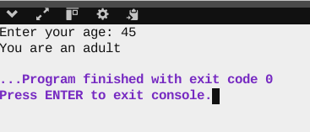

* Problem 2:

Source code:

#include <stdio.h>

int main()

{

int n;

printf("Enter a number: ");

scanf("%d",&n);

if (n>0)

{

printf("Number is positive");

if (n%2==0)

printf("\nNumber is even");

else

printf("\nNumber is odd");

}

else if (n=0)

printf("Number is zero");

else

printf("Number is negative");

}

Output:

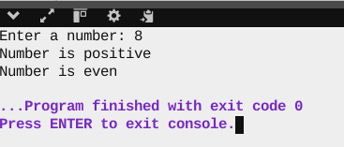

* Problem 3:

Source code:

#include <stdio.h>

int main()

{

int n;

printf("Enter a number: ");

scanf("%d",&n);

if (n%3==0)

{

if (n%5==0)

printf("Number is divisible by both 3 and 5");

else

printf("Number is not divisible by 5");

}

else

printf("Number is not divisible by 3");

}

Output:

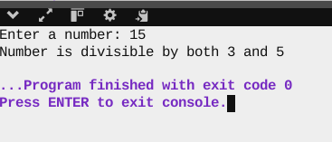

* Problem 4:

Source code:

#include <stdio.h>

int main()

{

int age;

char n;

printf("Enter your age: ");

scanf("%d",&age);

printf("Enter your nationality(P for Pakistan): ");

scanf(" %c",&n);

if (age>=18)

{

if(n=='P')

printf("You are eligible for voting in Pakistan");

else

printf("You are not eligible for voting in Pakistan");

}

else

{

printf("Age not matched!Not eligible for voting");

}

}

Output:

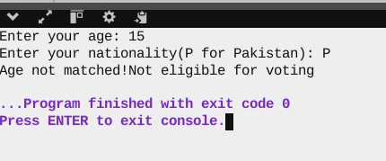

* Problem 5:

Source code:

#include <stdio.h>

int main()

{

int a,b;

printf("Enter 2 numbers: ");

scanf("%d%d",&a,&b);

a>b?printf("%d is greatest",a):printf("%d is greatest",b);

Output:

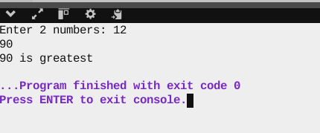

* Problem 6:

Source code:

#include <stdio.h>

int main()

{

int a;

printf("Enter a number: ");

scanf("%d",&a);

a>0?printf("%d is positive",a):a<0?printf("%d is negative",a):printf("%d is zero",a);

}

Output:

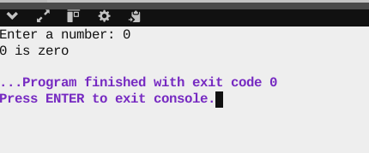

* Problem 7:

Source code:

#include <stdio.h>

int main() {

int a,b;

printf("Enter 2 numbers for swapping: ");

scanf("%d%d",&a,&b);

a=a^b;

b=a^b;

a=a^b;

printf("%d\n%d",a,b);

}

Output:

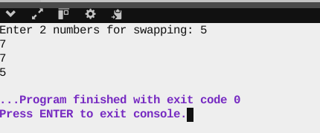

* Problem 8:

Source code:

#include <stdio.h>

int main()

{

int n, count = 0;

printf("Enter an integer: ");

scanf("%d", &n);

while (n > 0)

{

if (n & 1)

count++;

n >>= 1;

}

printf("Number of 1s in the binary representation is: %d\n", count);

}

Output:

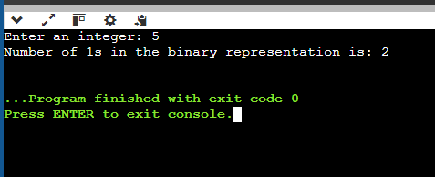

* Problem 9:

Source code:

#include <stdio.h>

int main() {

int year;

printf("Enter the year: ");

scanf("%d",&year);

if ((year%4==0 && year%100!=0)||(year%400==0))

printf("%d is a leap year",year);

else

printf("%d is not a leap year",year);

}

Output:

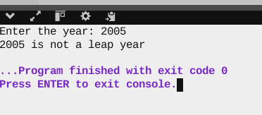

* Problem 10:

Source code:

#include <stdio.h>

int main() {

int num,sum=0;

printf("Enter a number: ");

scanf("%d",&num);

while (num>0)

{

sum=sum+(num%10);

num=num/10;

}

printf("Sum is: %d",sum);

}

Output:

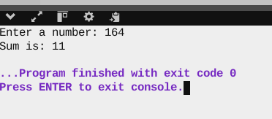

* Problem 11:

Source code:

#include <stdio.h>

int main() {

int a,b,c;

printf("Enter 3 numbers: ");

scanf("%d%d%d",&a,&b,&c);

if (a>b)

{

if (a>c)

printf("%d is the greatest",a);

else

printf("%d is the greatest",c);

}

else

{

if (b>c)

printf("%d is greatest",b);

else

printf("%d is greatest",c);

}

}

Output:

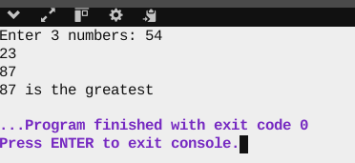

* Problem 12:

Source code:

#include <stdio.h>

int main() {

int at,as,ex,total;

printf("Enter attendance out of 20: ");

scanf("%d",&at);

printf("Enter assignment scores out of 30: ");

scanf("%d",&as);

printf("Enter exam scores out of 50: ");

scanf("%d",&ex);

total=(at+as+ex);

if (total>=90&&total<=100)

printf("Garde is A+");

else if (total>=80&&total<90)

printf("Grade is A");

else if (total>=70&&total<80)

printf("Grade is B");

else if (total >=60&&total<70)

printf("Grade is C+");

else if (total>=50&&total<60)

printf("Grade is C");

else if(total<50)

printf("Grade is F");

else

printf("Invalid input");

}

Output:

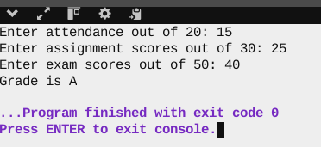

* Problem 13:

Source code:

#include <stdio.h>

int main()

{

char c,ec,key,dc;

printf("Enter the character and key: ");

scanf(" %c %c",&c,&key);

ec=c^key;

dc=ec^key;

printf("Encrypted character is: %c",ec);

printf("\nDecrypted character is: %c",dc);

}

Output:

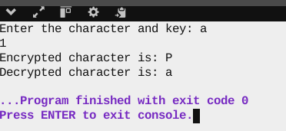

* Problem 14:

Source code:

#include <stdio.h>

int main() {

int age,inc,cs;

printf("Enter your age: ");

scanf("%d",&age);

printf("Enter your income: ");

scanf("%d",&inc);

printf("Enter your credit score out of 100: ");

scanf("%d",&cs);

if (age>=20&&age<=60)

{

if ((inc>=30000)&&(cs>50))

printf("You are eligible for loan");

else

printf("Not eligible for loan");

}

else

printf("Not eligible for loan");

}

Output:

